**Create Database**

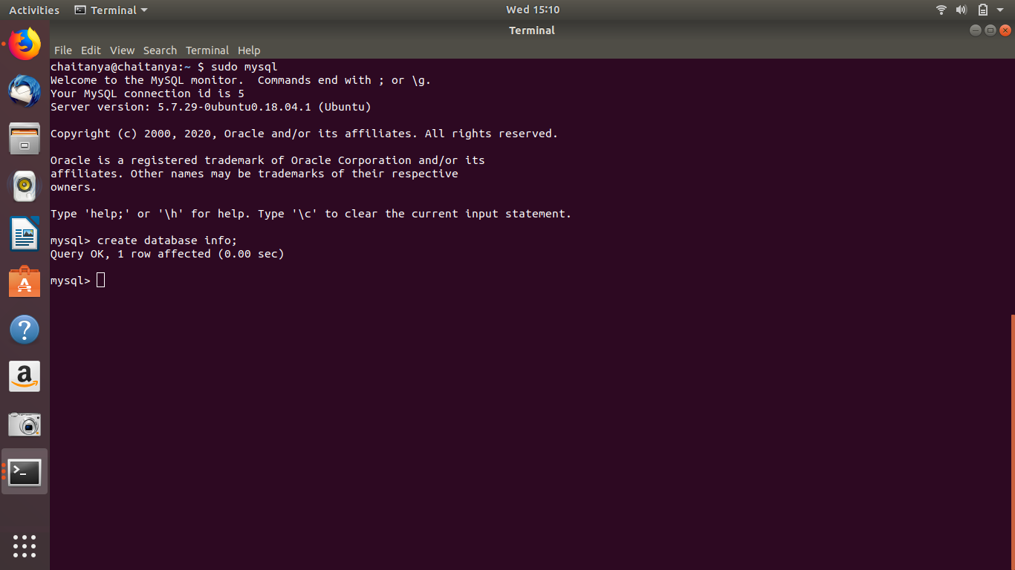

**Design Schema and Create tables**

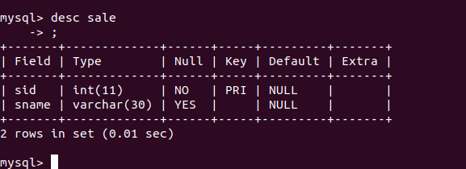

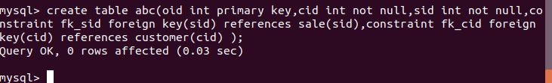

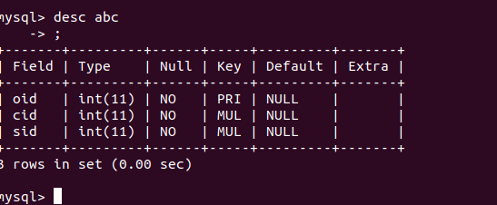

**Insert sample data**

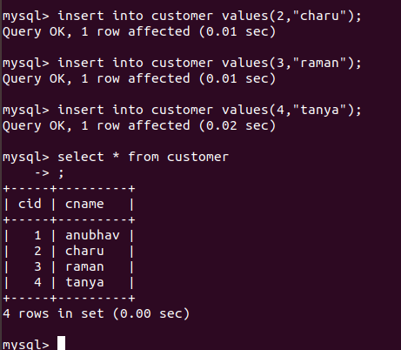

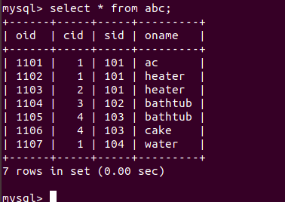

**Find the sales person have multiple orders.**

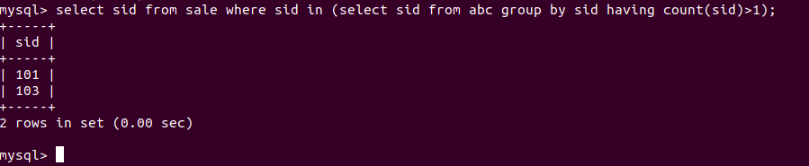

**Find the all sales person details along with order details**

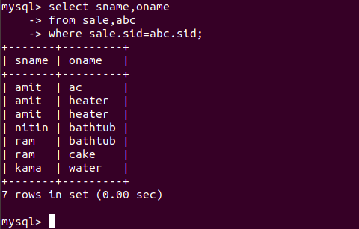

**Find the order number, sales person name, along with the customer to whom that order belongs to**

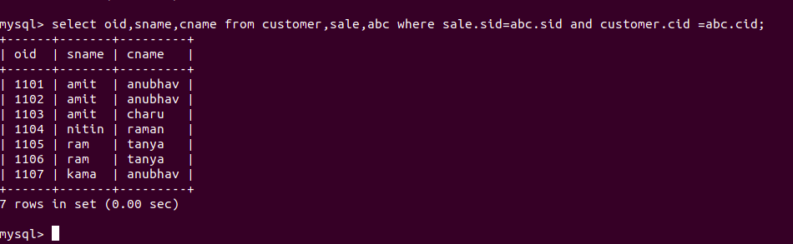

**Create index**

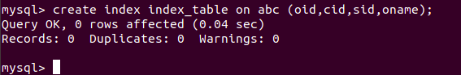

**How to show index on a table**

